ORIGIN OF THE UNIVERSE

When and how did the universe begin? Was there a beginning? Perhaps it was always there. If there was a beginning, will there be an end? The study of the answers to these questions is called cosmology.

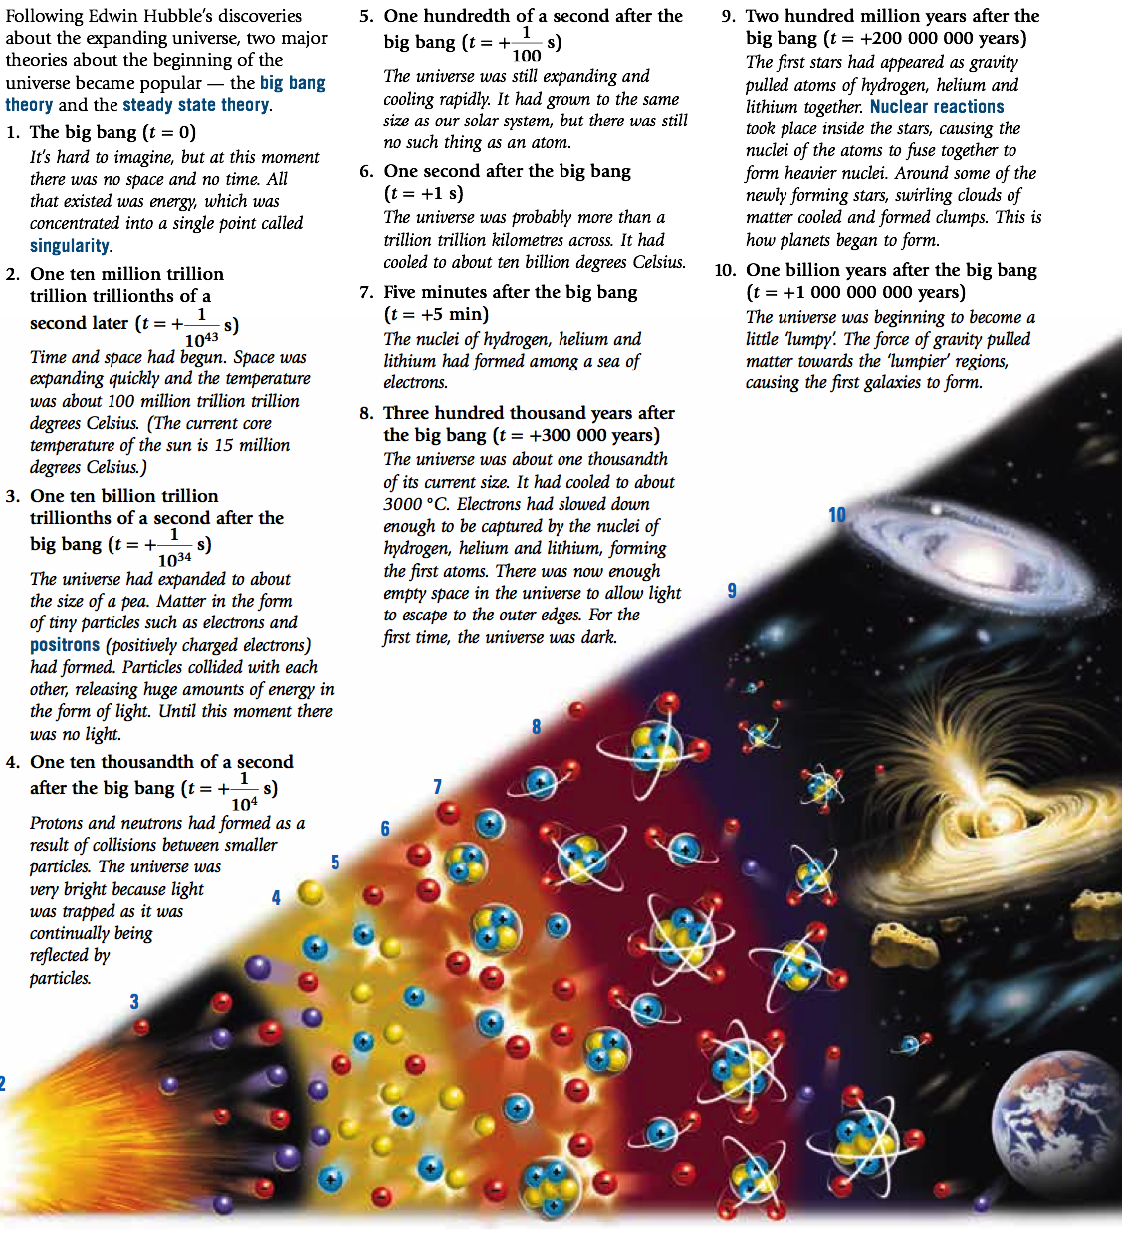

THE BIG BANG

According to the most commonly accepted theory among cosmologists, the universe began about 15 billion years ago with a ‘big bang’. This is better described as "The Big Expansion".

At the beginning, all that existed was energy, which was concentrated into a single point called a singularity.

The Einstein connection

The singularity before the Big Bang was not ‘nothing’. It was a huge amount of energy (with no mass) concentrated into a tiny, tiny point.

Einstein proposed that energy could be changed into matter. His equation E = mc² describes the change.

E represents the amount of energy in joules.
m represents the mass in kilograms.
c is the speed of light in metres per second (300 000 000 m/s).

Einstein’s equation also describes how matter can be changed into energy. That is what happens in nuclear power stations, nuclear weapons and during the fusion process in stars.

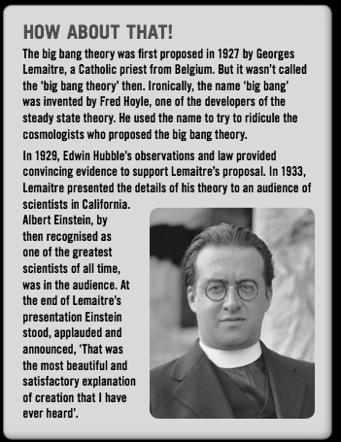

The Steady State Theory

According to the Steady State Theory, which was proposed in 1948 by Fred Hoyle, there was no beginning of the universe. It was always there.

The galaxies are continually moving away from each other. In the extra space left between the galaxies, new stars and galaxies are created.

These new stars and galaxies replace those that move away, so that the universe always looks the same.

A huge debate between those who supported the Steady State Theory and those who supported the Big Bang Theory raged from 1948 until 1965. During that period, the evidence supporting the Big Bang Theory grew.

Supporting Evidence

• The red shift

The red shift provides evidence for an expanding universe. This evidence supports the Big Bang Theory and causes problems for those supporting the Steady State Theory.

A Steady State universe could expand only if new stars and galaxies replaced those that moved away. These young stars and galaxies have not been found by astronomers.

• The elements

The amounts of hydrogen and helium in the universe support the Big Bang Theory. The amount of helium in the universe is greater than that proposed by the Steady State theory, but it can be explained by its creation as a result of the Big Bang.

• The afterglow

When George Gamow and Ralph Alpher proposed their version of the Big Bang Theory in 1948, they calculated that the universe would now, about 15 billion years after creation, have a temperature of 2.7°C above absolute zero (about -270°C).

Gamow predicted that, because of its temperature, the universe would be emitting an ‘afterglow’ of radiation. This afterglow became known as cosmic microwave background radiation, which was discovered in 1965.

Its discovery put an end to the Steady State Theory, leaving the Big Bang Theory as the only theory supported by evidence currently available.

• Cosmic Microwave Background Radiation

The background radiation detected was released only 380 000 years after the Big Bang — the first radiation to escape.

The image shows how the temperature varied across the universe as it was 380 000 years after the Big Bang.

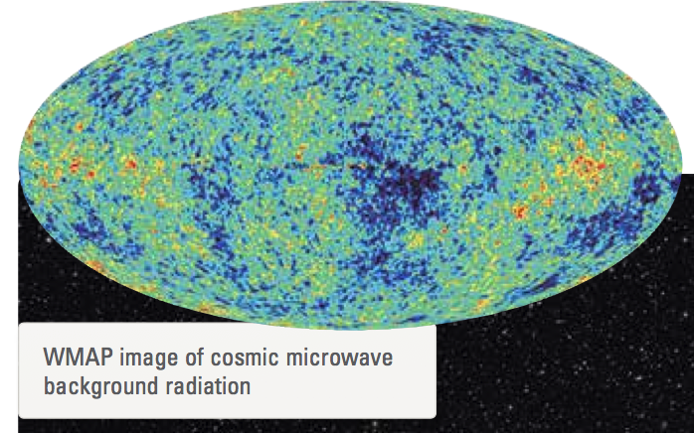

The blue parts of the map are the cooler regions. These regions were cool enough for atoms, and eventually galaxies, to form.

The red parts are warmer regions.

The map shows that galaxies are not evenly spread throughout the universe. They support the theory of an expanding universe that began with a Big Bang.

What is the future?

Will the expansion of the universe continue forever? If the universe does stop expanding, what will happen to it?

There are several competing theories about the answers to these questions.

One theory suggests that there is not enough mass in the universe for gravity to be able to pull it all back, so it will continue to expand forever.

Other theories suggest that the universe will eventually end. According to these theories, the end will come when:

• The universe snaps back onto itself in a ‘big crunch’ (the Big Crunch Theory). The end result will be a single point — singularity.
Some cosmologists believe that the Big Crunch will be followed by another Big Bang.

• The expansion of the universe continues and stars use up their fuel and burn out, causing planets to freeze (the Big Chill Theory).
The universe would then consist of scattered particles that never meet again.

• The universe rips itself apart violently as a result of expanding at an increasing speed (the Big Rip Theory).
According to this theory, the end of the universe will also be the end of time itself.

